Assignment
Fundamental Theory
(LAB: 5)
NAME: Majid Ali
CMS ID: 053-25-0017
PROGRAM: Software engineering (Section: A)
Question 1:
Write a program that should ask the user to input his/her marks of one subject (out of 100). Then, it should tell the CGPA according to his/her marks. Details/rules of the CGPA are given below:
Marks | CGPA
93 (or above) | 4.00
87 to 92 | 3.67
82 to 86 | 3.33
77 to 81 | 3
72 to 76 | 2.67
68 to 71 | 2.30
64 to 67 | 2.00
60 to 63 | 1.67
60 to 63 | 0.00
#include <iostream>
using namespace std;
int main(){
int marks;
cout<<"Enter the marks:"<<endl;
cin>>marks;
if(marks>=93 && marks<=100){

cout<<"CGPA: 4"<<endl;}
else if(marks>=87 && marks<93){

cout<<"CGPA: 3.67"<<endl;}
else if(marks>=82 && marks<=86){

cout<<"CGPA: 3.33"<<endl;}
else if(marks>=77 && marks<=81){

cout<<"CGPA: 3"<<endl;}
else if(marks>=93 && marks<=100){

cout<<"CGPA: 4"<<endl;}
else if(marks>=72 && marks<=76){

cout<<"CGPA: 2.67"<<endl;}
else if(marks>=68 && marks<=71){

cout<<"CGPA: 2.30"<<endl;}
else if(marks>=64 && marks<=67){
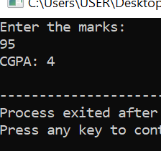
cout<<"CGPA: 2.00"<<endl;}
else if(marks>=60 && marks<=63){
cout<<"CGPA: 1.67"<<endl;}

else if (marks>0 && marks<=59){
cout<<"CGPA: 0.00 "<<endl;}
return 0;
}

Question 2:
Write the program where you ask the user to input his/her marks for five subjects and calculated his/her obtained marks and percentage. So, after calculating the percentage, you should also tell his/her grade according to the rules given below:
Marks | Grade
90 (or more) | A1
80 to 89 | A
70 to 79 | B
60 to 69 | C
Less than 60 | F
#include <iostream>
using namespace std;
int main(){
int marks;
cout<<"Enter the marks:"<<endl;
cin>>marks;
if(marks>=90 && marks<=100){
cout<<"Grade: A1"<<endl;}
else if(marks>=80 && marks<=89){
cout<<"Grade A"<<endl;}
else if(marks>=70 && marks<=79){
cout<<"Grade: B"<<endl;}
else if(marks>=60 && marks<=69){
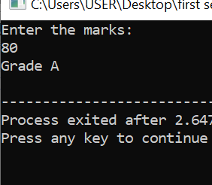
cout<<"Grade: C"<<endl;}
else if (marks<60){
cout<<"F"<<endl;}
return 0;
}

Question 3:
Write a program that prompts the user to enter a vehicle's speed and the speed limit. Use the conditional statement to determine and display whether the vehicle is within the speed limit or if it's speeding. If it's speeding, calculate and display the fine amount as follows: $10 for every 5 mph (mile per hour) over the limit.
#include <iostream>
using namespace std;
int main(){
float vehicle_speed;
float speed_limit;
float over_speeding,fine;
cout<<"Enter the Vehicle speed: ";
cin>>vehicle_speed;
cout<<"Enter the speed limit: ";
cin>>speed_limit;
if(vehicle_speed<=speed_limit){
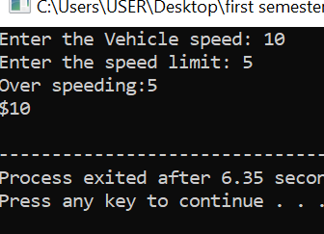
cout<<"The vehicle is within the speed limit"<<endl;
}
else{
over_speeding=vehicle_speed-speed_limit;
fine=(over_speeding/5)*10;
cout<<"Over speeding:"<<over_speeding<<endl;
cout<<"$"<<fine<<endl;
}
return 0;
}

Question 4:
Write a program that prompts the user to input a number. The program should then output the number and a message saying whether the number is positive, negative, or zero.
#include <iostream>
using namespace std;
int main(){
int num;
cout<<"Enter the number: ";
cin>>num;
if(num>0){
cout<<"positive"<<endl;
}
else if(num==0){
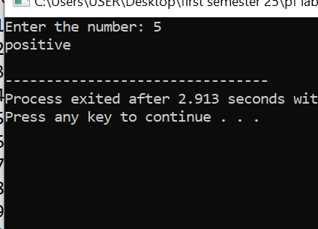
cout<<"Zero"<<endl;
}
else {
cout<<"negative"<<endl;
}
return 0;
}

Question 5:
Write a program that asks the use to input any month number in integer (like 1, 2… 12) and display the respective month name in the word (like January, February… December).
#include <iostream>
using namespace std;
int main(){
int mon;
cout<<"Enter the month number:";
cin>>mon;
if(mon==1){
cout<<"January"<<endl;
}
else if(mon==2){
cout<<"February"<<endl;
}
else if(mon==3){
cout<<"March"<<endl;
}
else if(mon==4){
cout<<"April"<<endl;
}
else if(mon==5){
cout<<"May"<<endl;
}
else if(mon==6){
cout<<"june"<<endl;
}
else if(mon==7){
cout<<"July"<<endl;
}
else if(mon==8){
cout<<"August"<<endl;
}
else if(mon==9){
cout<<"September"<<endl;
}
else if(mon==10){
cout<<"October"<<endl;
}
else if(mon==11){
cout<<"November"<<endl;
}
else if(mon==12){
cout<<"December"<<endl;
}
return 0;
}

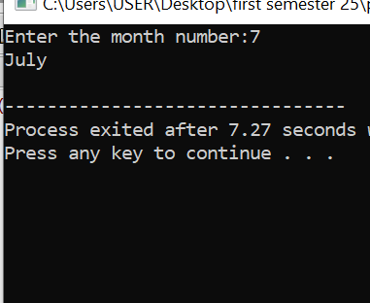

Question 6:
Write a C++ program that asks the user to input two numbers and tell a) if the first number is greater than the second number b) if the second number is greater than the first one c) or both numbers are equal
#include <iostream>
using namespace std;
int main(){
int num1,num2;
cout<<"Enter the number one: ";
cin>>num1;
cout<<"Enter the number two: ";
cin>>num2;
if(num1>num2){
cout<<" First number is greater than the second number"<<endl;
}
else if(num2>num1){
cout<<"Second number is greater than the first number"<<endl;
}
else if(num1=num2){
cout<<"Both numbers are equal "<<endl;
}
return 0;
}
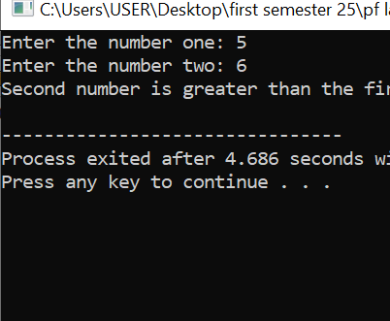

Question 7:
Write a C++ program that asks the user to input two numbers and tell a) if the first number is greater than the second number b) if the second number is greater than the first one c) or both numbers are equal 7. Write a C++ program that asks a user to input three numbers and tell which one is the largest of them. See the sample outputs below:
#include <iostream>
using namespace std;
int main(){
int num1,num2,num3;
cout<<"Enter the number one: ";
cin>>num1;
cout<<"Enter the number two: ";
cin>>num2;
cout<<"Enter the number three: ";
cin>>num3;
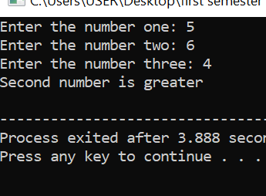
if(num1>num2&& num1>num3){
cout<<" First number is greater "<<endl;
}
else if(num2>num1 && num2>num3){
cout<<"Second number is greater"<<endl;
}
else if(num3>num1 && num3>num2){
cout<<"Second number is greater"<<endl;
}
return 0;
}

Question 8:
Write a C++ program that asks a user to input two numbers and then the operator (+ or – or * or / etc.) to show which operation is to be performed on those two numbers. Like shown below:
#include <iostream>
using namespace std;
int main(){
int num1,num2;
int Add,sub,mul,divi;
char sign;
cout<<"Enter the num1: ";
cin>>num1;
cout<<"Enter the operation: ";
cin>>sign;
cout<<"Enter the num2: ";
cin>>num2;
if(sign=='+'){
Add=num1+num2;
cout<<"Addition is:"<<Add<<endl;}
else if(sign=='-'){
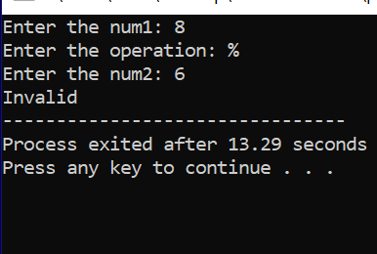
sub=num1-num2;
cout<<"subtraction is:"<<sub<<endl;}
else if(sign=='*'){
mul=num1*num2;
cout<<"Multiplication is:"<<mul<<endl;}
else if(sign=='/') {
divi=num1/num2;
cout<<"Division is:"<<divi<<endl;}
else
cout<<"Invalid";
return 0;
}
Question 9:
Create a program that prompts the user to enter the temperature in Celsius. Determine whether it's a "hot day," a "moderate day," or a "cold day" based on the following conditions:
• Hot: Temperature is above 30°C
. • Moderate: Temperature is between 20°C (inclusive) and 30°C (exclusive).
• Cold: Temperature is 20°C or below.
#include <iostream>
using namespace std;
int main(){
int temp;
cout<<"Enter the temperature:";
cin>>temp;
if(temp>30)
cout<<"It is hot day"<<endl;
else if(temp>=20 && temp<=30){
cout<<"It is moderate day"<<endl;
}
else if(temp<20){
cout<<"It is Cold day"<<endl;
}
return 0;
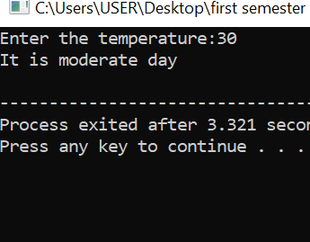
}

Question 10:
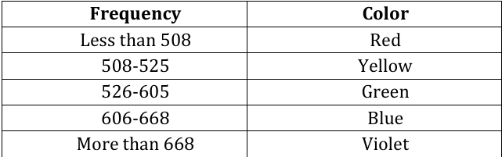
Write a program that asks the frequency of color and print the corresponding color as given in the table below: Frequency Color Less than 508 Red 508-525 Yellow 526-605 Green 606-668 Blue More than 668 Violet

#include <iostream>
using namespace std;
int main() {
int frequency;
cout << "Enter the frequency of color: ";
cin >> frequency;
if (frequency<508) {
cout<<"Color: Red"<<endl;
}
else if (frequency>=508 && frequency<= 525) {
cout<<"Color: Yellow"<<endl;
}
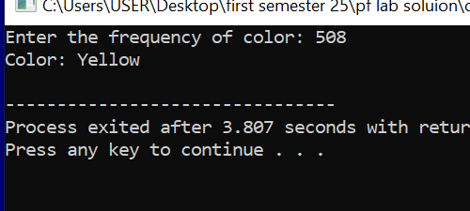
else if (frequency>=526 && frequency<= 605) {
cout<< "Color: Green"<< endl;
}
else if (frequency >= 606 && frequency<= 668) {
cout<<"Color: Blue"<<endl;
}
else if(frequency>608) {
cout<<"Color: Violet"<<endl;
}

return 0;
}
Switch Statements Tasks
Question 1:
Write a program that asks the user to input two numbers and an operator (+, -,*, or /), and then perform the operation (addition, subtraction, multiplication, or division) on the two entered numbers according to the operator input by the user. If the entered operator is not from these four operators, the program should display an error message saying that the entered operator is invalid.
#include <iostream>
using namespace std;
int main(){
int num1,num2;
int add,sub,mul,divi;
char sign;
cout<<"Enter the number one: ";
cin>>num1;
cout<<"Enter the operation: ";
cin>>sign;
cout<<"Enter the number two: ";
cin>>num2;
switch(sign){
case '+':
cout<<"Addition: "<<num1+num2<<endl;
break;
case '-':
cout<<"Substraction: "<<num1-num2<<endl;
break;
case '*':
cout<<"Multiplication: "<<num1*num2<<endl;
break;
case '/':
cout<<"Division: "<<num1/num2<<endl;
break;
default:
cout<<"Invalid"<<endl;
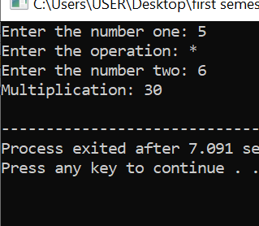
}
return 0;
}

Question 2:
Write a program that should ask the user to input a month number (from 1 to 12) and then display the respective month name in words (like January for 1, February for 2 and so on). If the user inputs value other than numbers from 1 to 12, the program should display a message saying that it is an invalid month number.
#include <iostream>
using namespace std;
int main(){
int month_number;
cout<<"Enter the month number: ";
cin>>month_number;
switch(month_number){
case 1:
cout<<"January"<<endl;
break;
case 2:
cout<<"February"<<endl;
break;
case 3:
cout<<"March"<<endl;
break;
case 4:
cout<<"April"<<endl;
break;
case 5:
cout<<"May"<<endl;
break;
case 6:
cout<<"June"<<endl;
break;
case 7:
cout<<"July"<<endl;
break;
case 8:
cout<<"August"<<endl;
break;
case 9:
cout<<"September"<<endl;
break;
case 10:
cout<<"October"<<endl;
break;
case 11:
cout<<"November"<<endl;
break;
case 12:
cout<<"December"<<endl;
break;
default:
cout<<"Invalid"<<endl;
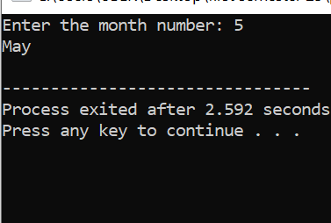
}
return 0;
}

Question 3:
Write a program that ask the user to input a month (from 1 to 12) and then display which season currently it is. The season should be displayed as per the following rules
• If the month number is 12 or 1 or 2, then it is the Winter season
• If the month number is 3 or 4, then it is the Spring season
• If the month number is 5 or 6 or 7 or 8 or 9, then it is the summer season
• If the month number is 10 or 11, then it is the Autumn season
#include <iostream>
using namespace std;

int main() {
int month_number;
cout<< "Enter month number: ";
cin>>month_number;

switch (month_number) {
case 12:
case 1:
case 2:
cout<< "Winter season" <<endl;
break;

case 3:
case 4:
cout<< "Spring season" <<endl;
break;

case 5:
case 6:
case 7:
case 8:
case 9:
cout<< "Summer season" <<endl;
break;

case 10:
case 11:
cout<< " Autumn season" <<endl;
break;
default:
cout<< "Invalid month number" <<endl;
}
return 0;
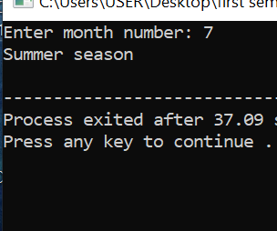
}

Question 4:
Write a program that should ask the user to input an alphabet character (small or capital) and tell if it is a vowel or a consonant.
#include <iostream>
using namespace std;
int main(){
char ch;
cout<<"Enter the character: ";
cin>>ch;
switch(ch){
case 'a':
case 'e':
case 'i':
case 'o':
case 'u':
cout<<"Vowel"<<endl;
break;

default:
cout<<"Consonant"<<endl;
}
return 0;
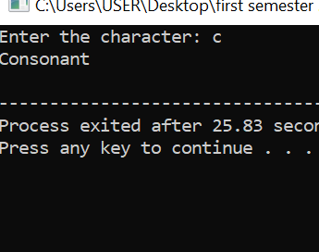
}

Question 5:
Write a program that should ask the user to input an integer number and print whether it is even or odd.

include <iostream>
using namespace std;
int main(){
int num;
cout<<"Enter the Number: ";
cin>>num;
switch(num%2){
case 0:
cout<<"Even"<<endl;
break;
default:
cout<<"Odd"<<endl;
}
return 0;
}

